FOR OFFICIAL USE
Programme Number:

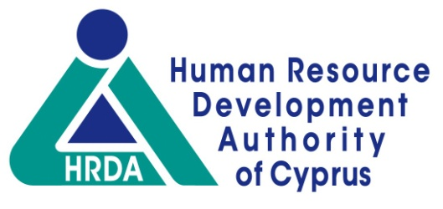
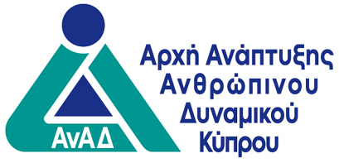

Request for utilisation

of distance e-learning methods

Information on Vocational Training Centre (VTC) or Company/Organisation
Name:
Certification No of VTC or Employer Social Insurance Registry No:
Email: | Phone no:

Scheme (please tick (√) the Scheme for which the application is submitted)
Standard Multi-Company Training Programmes
High Priority Multi-Company Training Programmes
Single-Company Training Programmes in Cyprus
Single-Company Training Programmes in Cyprus (State Aid)
Continuing Training Programmes for Trade Union Officials
Special Scheme for Training of the Employed in Specific Economic Sectors Affected by the Pandemic

Information on training programme
Title |  | Number  (where applicaple)
Current status regarding the implementation of the programme:

Synchronous and Asynchronus e-learning tools and way of utilisation

OFFICIAL STATEMENT

(a) In accordance with the EU General Data Protection Regulation (GDPR) and the Protection of Individuals with regard to the Processing of Personal Data and the Free Movement of such Data, Law of 2018 [Law No.125(I)/2018], personal data submitted or likely to be submitted in connection with this application shall be legally, fairly and transparently collected to allow the HRDA to process it. In addition, our employees/executives/members/associates and/or unemployed persons whose personal data are submitted or may be submitted in connection with this application are informed of the HRDA's Privacy Policy as posted on its website www.anad.org.cy.
(b) The VTC/company/organisation that I represent intends and can utilise distance learning methods in the training programme for which it is applying for or which has already been approved.
(c) Being fully aware of the consequences of the Criminal Code regarding false representations and in general the law on false representations, all the information recorded in this application is accurate and true.
(d) We are fully aware of the provisions of the Human Resource Development Laws, as well as the provisions of the Policy and Procedures Guide of the Scheme we apply for, and the E-Learning Supplement, and we accept and commit to their faithful observance. We also know about the HRDA's ability to impose sanctions in the event of a breach of its Laws provisions, the Policy and Procedures Guide under which the application is made, the E-Learning Supplement and/or related legislation.

__________________________________ | _____________________ | _____________________
Name and surname of  Director or  Authorised Representative | Signature  and official stamp of  company/organisation | Date

